Every Second Count

By We are Steve.

**Update Log:**

| **Team Members** | **Task Allocation** |
| --- | --- |
| Junhao, Cherry, Hazwan, Eric, Minh Quan | Game Design Document |
| Junhao, Cherry, Hazwan, Eric, Minh Quan | Proof-of-concept Development |
| Junhao, Cherry, Hazwan, Eric, Minh Quan | Playtesting |

## High Concept

* + A single player 2D top down text based game in which the protagonist is stuck in a time loop with the goal of escaping death by a robber within a 15 minute time frame where every decision can lead to a different ending.

## Features

* Time loop
* Problem solving
* Multiple endings
* Player Decisions
* Different Rooms based on the house design layout

# **Game Overview**

## Game Theme / Setting / Genre

* + Time Loop, Modern, Supernatural

## Targeted platforms

* 1. Windows , on pc

## Target Audience

* 1. Age :  
     12 to 50 years old
  2. Gender :   
     All
  3. Demographic :  
     For those who like text based game, thriller, suspense and problem solving

## Project Scope

* 1. Gameplay duration scale :  
     30 minutes
  2. Cost :  
     free

# 

# **Design Goals**

## Challenge:

Player enters a time loop after getting killed by a murderer. His goal then becomes to survive this murder through the interaction of objects within his home.

## Fantasy:

Supernatural setting with time looping where game “restarts” if player dies

## Sensation:

Surviving or completing an ending gives a sense of accomplishment.

## Influences

* 1. Inspiration :   
     12 Minutes, The Man From The Window, Written Realms
  2. Values to user :

It makes the user think strategically and it improves the user’s problem solving skills

* 1. Player Motivation :  
     The player’s motivation is to escape the time loop alive

## The Elevator Pitch

* 1. What is the Game Project about?

A 2D Single-player interactive game where the protagonist is forced to prevent his own death. The interactive features of the game allows the player to affect his own ending by interacting with objects which can save him.

* Unique Selling Point
  + Time loop game

## Monetization model

* 1. Free game
  2. In-game purchases

# **Story and Gameplay**

# Storyline: Protagonist getting murdered.

## Protagonist came back home from work, then a few minutes after

## The house got cut from power and phone lines have been severed. Then he finds

## out that the killer has broken into his house and gets murdered.

## The story restarts and he realizes that he is stuck in a 12-15 minute time loop depending on his actions and his goal is to survive.

## The Protagonist tries to buy enough time for the police to arrive and

## arrest the killer.

## 

## Gameplay Mechanics

* 1. Controls
* “W”, “A”, “S, “D” to move
* player options include “ Options: E , Interact, Move, menu, help” after clicking “/”
* Enter and exit for door transitioning
* -interact to trigger item dialogue and interaction
* move to set movement to player active again
* menu to display main menu that can lead to to different endings unlocked or continue.

* 1. Win or lose logic  
     You win if you do the correct actions and decisions that will lead you to the end.  
     You lose if you fail to buy enough time before the police arrive or fail to fight back.

## Gameplay Flowchart

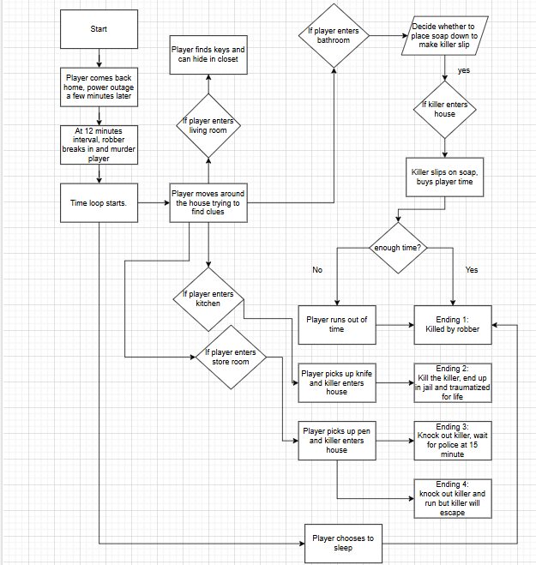

# 

# 

# 

# 

# 

# 

# 

# 

# 

# 

# 

# 

# 

# 

# 

# **3. Game Art**

## Game Characters

| **Name** | **Description** | **Image** |
| --- | --- | --- |
| Player | you |  |

## Game Environment

| **Name** | **Description** | **Image** |
| --- | --- | --- |
| Living Room | Living room with sofa, table, television and cabinet. Access to all 4 four rooms. |  |
| Kitchen | Kitchen with stove, fridge and sink. |  |
| Bedroom | Bedroom with bed, table, cabinets |  |
|  | Store room with boxes and planks |  |
|  | Toilet with shower area and toilet bowl. |  |

# **4. User Interface**

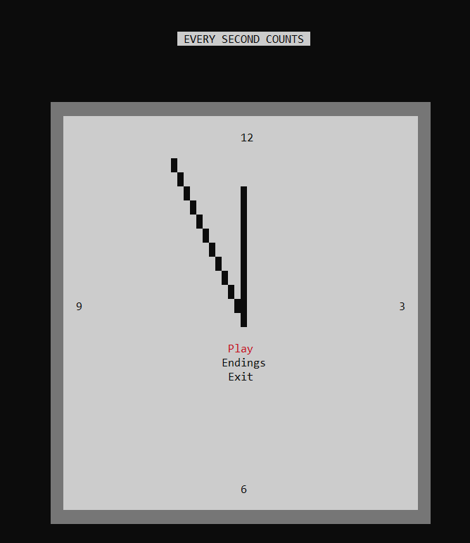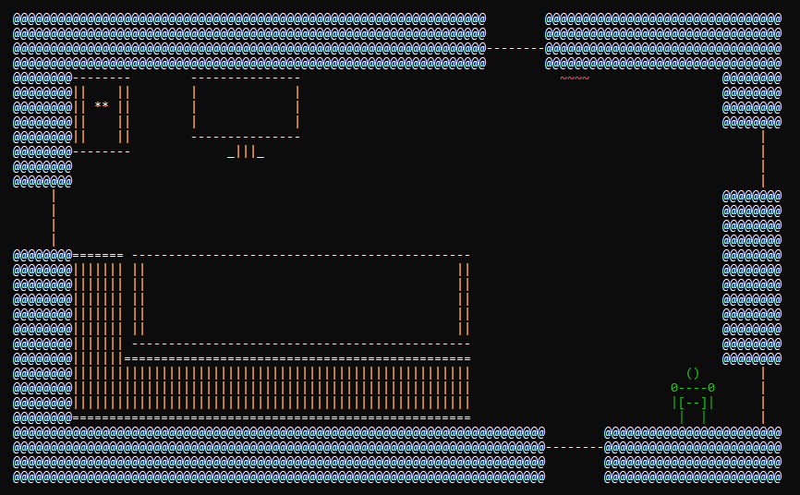

^ (Main Menu) ^ (Game UI)

Designed to be simple and easy to understand with minimal texts and objects.

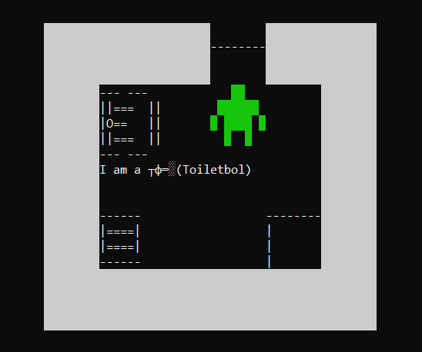

# **5. Concept Art**

# 